Project Design Phase
Solution Architecture
SpendWise · Backend Learning Project

▌ Document Information

Date | 8 March 2026
Team ID | SWTID-2026-1005
Project Name | SpendWise

▌ Architecture Overview

The solution architecture for SpendWise ensures a simple, scalable, and easy-to-understand backend system for beginners to learn JWT authentication, REST API development, and MongoDB integration.
SpendWise follows a client–server architecture where the client (Postman / Thunder Client or an optional frontend) sends HTTP requests to the backend API. The backend handles authentication, business logic, and database operations, while MongoDB stores all user and record data.

▌ Core Technology Stack

⚙️  Node.js  Runtime Engine | 🚀  Express.js  REST API Framework | 🗄️  MongoDB  Database (Mongoose) | 🔐  JWT  Auth & Security

▌ Goals of the Solution Architecture

A | Identify the Best Tech Solution  ◆ Node.js + Express.js — Build RESTful APIs efficiently with a lightweight framework.  ◆ MongoDB + Mongoose — Schema-driven data storage and seamless database operations.  ◆ JWT Authentication — Secure token-based user authentication and route authorization.  ◆ Postman / Thunder Client — API testing, validation, and live demonstration.

B | Define Structure & Characteristics  ◆ Modular folder structure: Controllers · Models · Routes · Middleware  ◆ Simple — Easy for beginners to read and follow.  ◆ Maintainable — Clear separation of concerns for future changes.  ◆ Scalable — Ready to extend with filters, frontend, or additional APIs.

C | Outline Development Phases  ◆ Phase 1 — Project setup and MongoDB connection  ◆ Phase 2 — User authentication: Register & Login with JWT  ◆ Phase 3 — JWT middleware for protecting routes  ◆ Phase 4 — CRUD operations on user data (Create, Read, Update, Delete)  ◆ Phase 5 — API testing with Postman / Thunder Client and documentation

D | Establish Specifications for Development & Delivery  ◆ REST APIs for both authentication and CRUD operations.  ◆ JWT token required on all protected routes.  ◆ MongoDB for secure and structured user data storage.  ◆ Clean codebase with an organized structure for learning and maintenance.  ◆ Local setup via Node.js with environment variable configuration.

▌ Development Phases at a Glance

Phase | Deliverable / Milestone
Phase 1 | Project Setup & MongoDB Connection
Phase 2 | User Authentication — Register & Login (JWT)
Phase 3 | JWT Middleware for Protected Routes
Phase 4 | CRUD Operations on User Data
Phase 5 | API Testing via Postman / Thunder Client & Docs

▌ Architecture Diagram

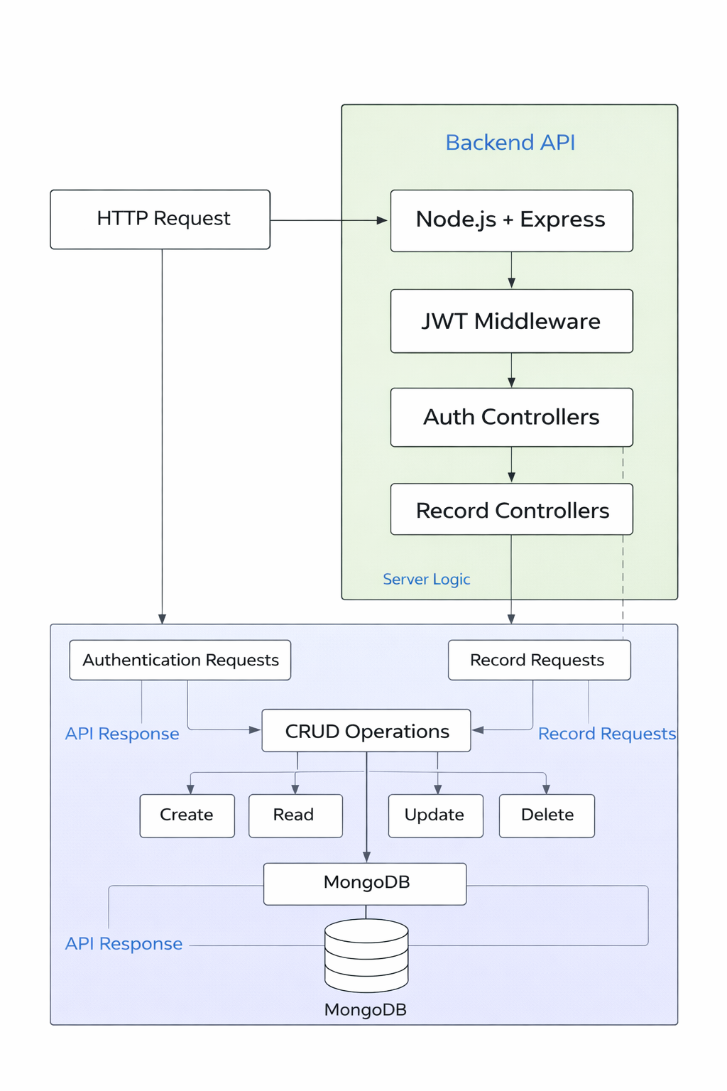
Figure 1 — SpendWise Client–Server Architecture

